CSCI 2467
Lab 3

- Write a program that prompts a user to enter an employee’s name, hours worked, hourly pay, federal and state tax rates. A sample run is below:

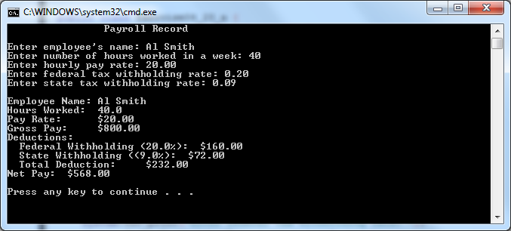

- Write a program that prompts the user to enter three cities and displays them in ascending order. A sample run is below:

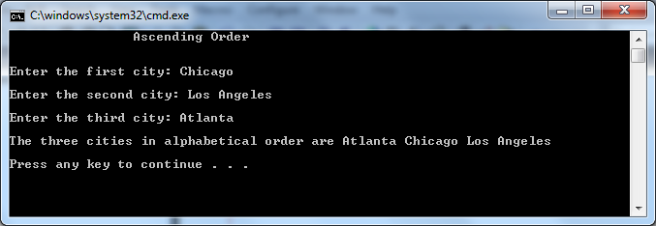
Submit both files via blackboard.

